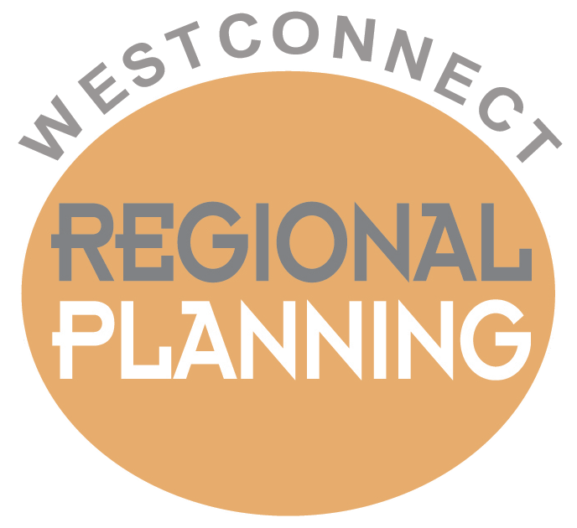

WESTCONNECT REQUEST FORM –
REGIONAL PLANNING DATA, NON-PUBLIC INFORMATION

Thank you for your interest in submitting a request for access to non-public WestConnect Regional Planning Data. All information considered by WestConnect to be non-public is protected under the WestConnect Non-Disclosure Agreement. Please review the agreement before proceeding with this request form.

If you are a member of the WestConnect Planning Management Committee (PMC):
Members of the WestConnect PMC are not required to fill out this request form and may directly sign the WestConnect Non-Disclosure Agreement, and return it as instructed within the agreement.

If you are not a member of the WestConnect PMC:
If you are not a member of the WestConnect PMC, you must complete the information requested below, and return this form together with a signed copy of the WestConnect Non-Disclosure Agreement to NDA@WestConnect.com. Once your request form and signed NDA have been received, the WestConnect PMC will review your request at its next regularly scheduled meeting. If your request is approved, you will be given access to the non-public WestConnect Regional Planning Data through the email address you provide in your request form.

If you are an employee of the Federal Energy Regulatory Commission:
If you are an employee of the Federal Energy Regulatory Commission (FERC) you do not need to complete this request form or the WestConnect Non-Disclosure Agreement. Please email your detailed request for access to the non-public WestConnect Regional Planning Data directly to NDA@WestConnect.com.

If you have any questions regarding this request form, please email your questions to NDA@WestConnect.com.

Please provide complete responses to the following questions:
Name: Click or tap here to enter text.
Title: Click or tap here to enter text.
Organization: Click or tap here to enter text.
Address: Click or tap here to enter text.
Phone Number: Click or tap here to enter text.
Email: Click or tap here to enter text.

Detailed Statement of Need:
Please explain why you are seeking access to non-public WestConnect Regional Planning Data, how you intend to use the data, and how long you require access to the data. Please provide as much detail as possible.
Click or tap here to enter text.

Have you or your entity previously requested access to non-public WestConnect Regional Planning Data?
Yes ☐
- Date of last request submittal, or Click or tap to enter a date.
- Date of execution of last signed WestConnect NDA Click or tap to enter a date.
No ☐

I attest that the information provided in this request form is true and accurate, and I agree to give the WestConnect PMC immediate notice if any of the provided information is no longer true. I also consent to the disclosure of the fact that this request has been made or granted, and I agree on behalf of myself and the individual or entity that I represent that WestConnect and any of its consultants or members have no liability, in connection to this request, to me or the individual or entity that I represent. Furthermore, I agree on behalf of myself and the individual or entity that I represent to indemnify, hold harmless, and defend the Westconnect PMC and its consultants and members from any third party claims whatsoever arising from this request.

Signature:
Name (please print): Click or tap here to enter text.
Date: Click or tap to enter a date.

Please submit your completed and signed request form and WestConnect NDA to:
Email: NDA@WestConnect.com
Re: WestConnect NDA

All PMC meetings are posted to the calendar available on the WestConnect website (www.westconnect.com)

